**BML Traffic Simulation**

In this simulation, we investigated traffic behavior using the BML model. The model simulates traffic flow by using a grid and cars going east and north, represented by red and blue, respectively. The goal of the model is to determine at what densities (denoted p) traffic jams and free flow occur. After implementing this for a variety of simulations for varying densities, grid sizes, and grid shapes, we were able to define a few properties of traffic behavior in the BML model.

To investigate the effects of density on traffic flow, we began by conducting simulations for varying densities on a 100 x 100 grid. We typically ran each experiment out to 3,000 steps, with the exception of going up to 10,000 steps to investigate mixed traffic flow. Images corresponding to these simulations are given below:

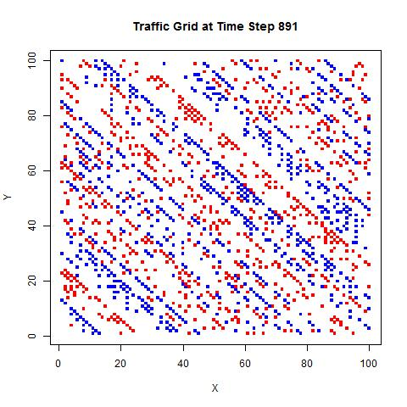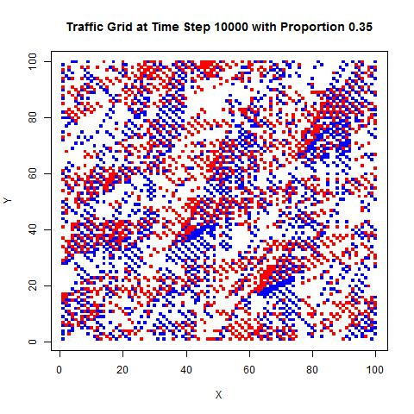

Fig. 2

Fig. 1

Fig. 2

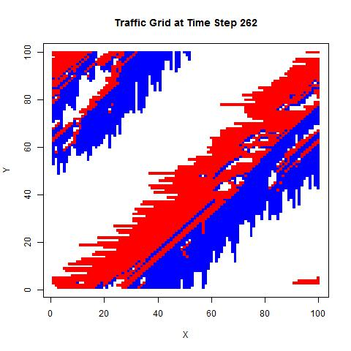

**Fig. 1** corresponds to free flowing traffic at a density of 0.15, whose end-state was determined by step 891. With this configuration, free flow occurred in all 20 trials run.

**Fig. 2** corresponds to mixed traffic at a density of 0.35, up to step 10,000. Mixed traffic occurred in all 8 trials run.

**Fig. 3** corresponds to complete gridlock at density 0.5, which occurred on the 262nd step. Complete gridlock occurred in all 20 trials run.

Fig. 3

We determined there was free flow if all cars moved for the number of time steps equal the lowest common multiple between the two grid dimensions. For example, in a 5 x 3 grid, if all the cars move for 15 time steps, then it is ensured that the grid state after the 15th step is identical to the original grid state. Therefore, the grid will cycle in an infinite free flow loop. To determine gridlock, there had to be one simulation step in which no cars moved.

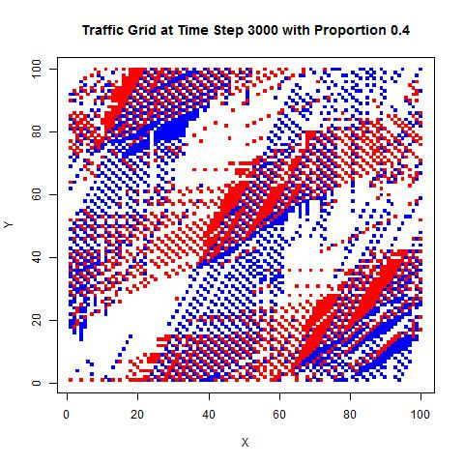Mixed traffic was defined as when the simulation ran out to the maximum number of time steps (i.e., 10,000) without hitting the above conditions. There often are indications of eventual free flow or traffic jam in the mixed traffic plots; for example, cars may be organizing into gridlock if there are large clusters of cars that are stuck **(Fig. 4)**, or may be approaching free flow if the cars are in a diagonal intersection pattern. On the other hand, there must be cases in which the grid is forever in mixed traffic (e.g., try out a 3 x 2 grid in which the top-left square contains a red car, and the middle-left square contains a blue car). We cannot fully distinguish between these two cases because we cannot run infinite iterations. It may be difficult to predict mixed traffic, versus gridlock or free flow, just by looking at the end-state plots.

We also investigated the effects of grid size on traffic flow. For one particular traffic simulation conducted for 100 random trials, 3,000 steps each, our findings are summarized below:

Fig. 4 – mixed traffic condition possibly headed toward traffic jam

|  |  |  |  |  |
| --- | --- | --- | --- | --- |
| **grid size** | **proportion of cars** | **% traffic jam** | **% free flow** | **% mixed** |
| 10 x 10 | 0.3 | 0 | 0.1 | 0.9 |
| 25 x 25 | 0.3 | 0 | 0.65 | 0.35 |
| 50 x 50 | 0.3 | 0 | 0.55 | 0.45 |
| 10 x 10 | 0.5 | 0.4 | 0 | 0.6 |
| 25 x 25 | 0.5 | 1 | 0 | 0 |
| 50 x 50 | 0.5 | 1 | 0 | 0 |

Gridlock tends to consistently occur at densities of 0.5 and above, but it is more difficult to reach gridlock for small grids. Free flow tends to occur at densities of 0.3 and below, but, interestingly, it is also more difficult to reach free flow in small grids. Densities between 0.3 and 0.5 tend to result in a mixed traffic state, akin to commute traffic, in which there is some non-immediate movement. Thus there appears to be other influences on traffic behavior aside from density alone.

The traffic behavior transitions are also affected by grid shape. Plots for two different 150 x 40 grids with p = 0.3 **(Fig. 5 and 6)**, and a 100 x 10 grid with p = 0.2 **(Fig. 7),** are shown below (note that the axes are not proportional):

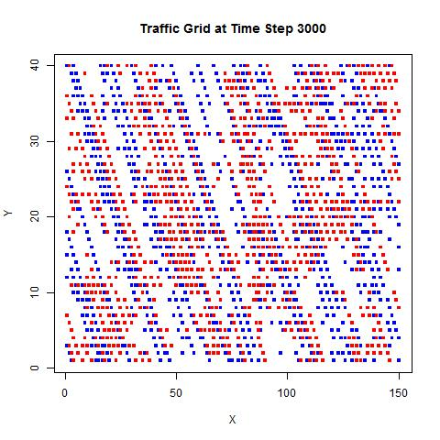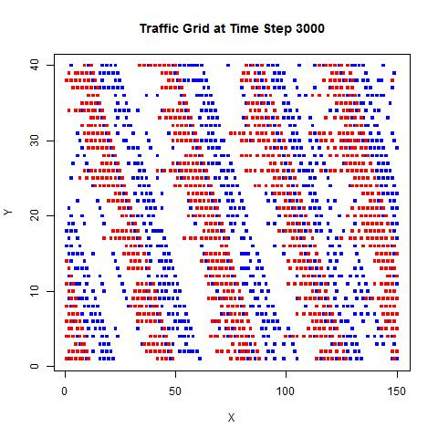

Fig. 5

Fig. 6

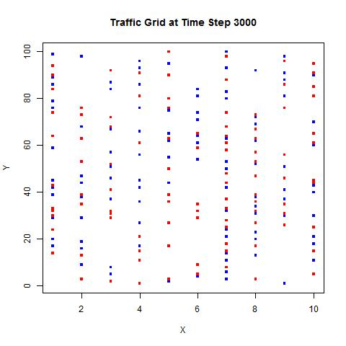

Similar to the smaller square grids, rectangular grids seem to make it harder to obtain either traffic jams or free flow, controlling for proportion of cars. More of the trials turn out as mixed traffic.

Fig. 7

We also examined the interaction between grid shape and traffic flow in a small case study. For small grid sizes with a fixed density of 0.3, we discovered that the shape of the grid does have a slight effect on traffic behavior, as shown (run for 100 trials each):

|  |  |  |  |  |  |  |  |  |  |
| --- | --- | --- | --- | --- | --- | --- | --- | --- | --- |
| **grid size** | **10 x 10** | **10 x 12** | **10 x 14** | **10 x 16** | **10 x 18** | **10 x 20** | **10 x 22** | **10 x 25** | **10 x 30** |
| **% free flow** | 0.17 | 0 | 0 | 0 | 0 | 0.03 | 0 | 0 | 0.01 |
| **% mixed** | 0.83 | 1 | 1 | 1 | 1 | 0.97 | 1 | 1 | 0.99 |
| **% traffic jam** | 0 | 0 | 0 | 0 | 0 | 0 | 0 | 0 | 0 |

A possibility is that grid size and grid shape have two separate effects on traffic flow. Larger grid sizes allow traffic to approach end conditions (free flow or traffic jam) sooner, while increasingly oblong rectangular grids slow down the rate of approaching the end condition. Therefore, when running a simulation like the small case study above, these two effects would counterbalance each other, and we wouldn’t see an immediately obvious trend when changing grid dimensions.

The results of our simulation study have shown that there are a few properties of traffic behavior in the BML model that do not have to do with traffic density. While density is primarily responsible for end-state traffic behavior, other factors such as grid size and grid shape may be influential for densities on the borderline between free flow and gridlock. Mixed states occur more frequently in small grids and irregularly-shaped grids at these sensitive density values. These relationships may be of some importance to more complex models and future traffic simulation studies.